TO: Josh Thomas, Director, Policy & Campaigns

CC:

From: Jaismine Kaur, Campaigns Assistant

Date: March 6, 2025

**RE: Squamish Frequent Transit Network Consultation**

# Purpose

This note is an overview of the Squamish Frequent Transit Network (FTN) consultation that recently started to highlight its impact on Capilano University (Squamish campus) students.

# Key Points

* BC Transit & District of Squamish are planning a new Frequent Transit Network (FTN) between Downtown Squamish and Garibaldi Village.
* Public consultation is now open, including an [online survey](https://engage.bctransit.com/squamish2025/surveys/squamish-local-area-transit-plan-public-survey) and in-person open houses on March 7 & 8.
* [The Squamish Transit Future Action Plan](https://engage.bctransit.com/squamish)  2022 also emphasized the need for frequent service and a second transit exchange at Garibaldi Village.

# News and Survey Summary

On **March 6, 2025,** BC Transit and the District of Squamish announced a public consultation on proposed transit improvements. The key proposal is a new Frequent Transit Network (FTN) route between Downtown Squamish and Garibaldi Village, and are now gathering public input to refine routes, frequency, and service hours.

The district says these changes align with the Squamish Transit Future Action Plan, which was endorsed by council in 2022.

This initiative follows the **Squamish Transit Future Action Plan (TFAP) 2015**, which identified the need for more frequent service and a second transit exchange in Garibaldi Village.

🔗[**Read more in the news here**](https://www.squamishreporter.com/2025/03/06/bc-transit-district-seek-feedback-on-new-bus-route-between-downtown-and-garibaldi-village/)

# Context and Suggestions

The Squamish Transit Future Action Plan (2022) suggests a new Frequent Transit Network (FTN) between Downtown and Garibaldi Village, likely replacing parts of routes **1 (Brackendale)** and **2 (Highlands)**. The FTN will eventually offer 15-minute service from 7 a.m. to 7 p.m. on weekdays, improving transit frequency.

**Original Transit Map:**

original squamish bus transit map


Option 1:

**FTN via Brennan Park:**

* FTN replaces part of Route 1 [Brackendale] and runs the route of **Downtown – Garibaldi Village – Brennan Park**.

Route 1 is split as follows:

* **FTN (new Route 1): Downtown → Garibaldi Village (via Brennan Park**).
* **New Route 6 (Brackendale – Garibaldi Village)** provides local service to Brackendale.
* **Route 2 Highlands** is shortened from Highlands → Downtown to **only serve between Capilano University, the Highlands, and Garibaldi Village**.
* Route 4 Garibaldi could stay as is, or **travel via Loggers Lane between Brennan Park and Industrial**. Longer term, there may be the option to extend route 3 Valleycliffe to the Adventure Centre.

**Likely Benefits**:

* FTN’s direct service to Brennan Park could be useful for recreation center users.
* Adjustments to route 4 could introduce new service along Loggers Lane. Another option would be for route 4 to remain as is, and travel to and from downtown via the highway.

**Potential Ineffectiveness**:

* Passengers, including students, may need to take an extra transfer at Garibaldi Village if they decide to travel from the FTN route. An FTN route between Garibaldi Village and Downtown would not effectively ensure a timely travel between Garibaldi Village and University.

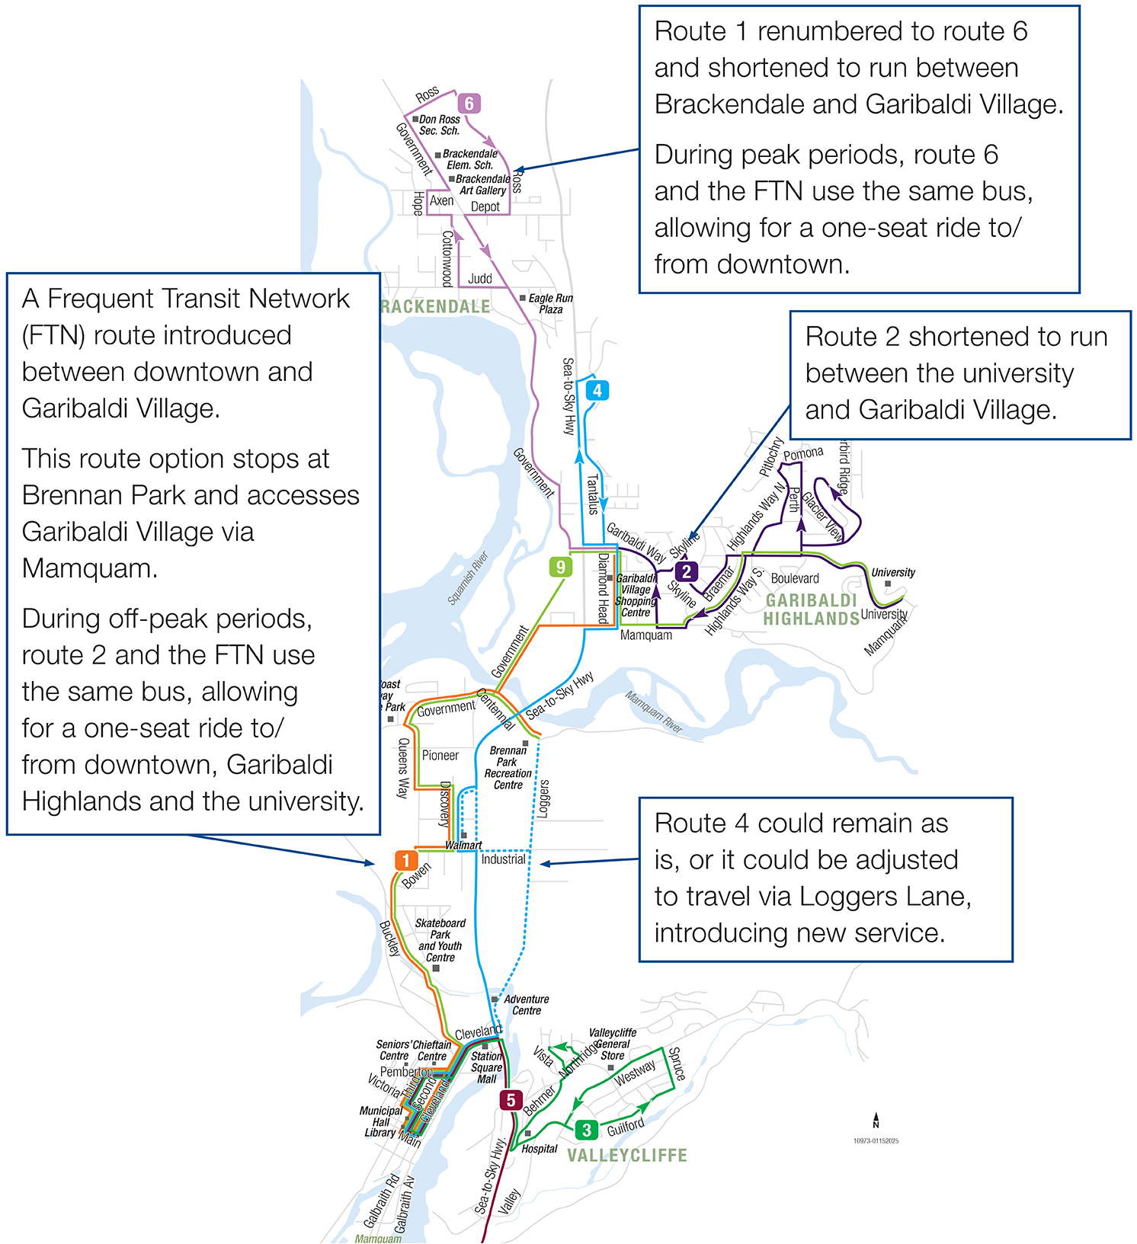

Option 2:

### FTN via Government Road:

* **FTN replaces part of Route 1 (Brackendale)** and runs the route of **Downtown – Garibaldi Village via Government Road**.

**Route 1 is split as follows:**

* **FTN (new Route 1):** Downtown → Garibaldi Village (via Government Road).
* **New Route 6 (Brackendale – Downtown):** Provides local service to Brackendale via the highway and Loggers Lane.
* Route 2 Highlands is shortened from **Highlands → Downtown** to only serve Capilano University, the Highlands, and Garibaldi Village.
* Route 4 Garibaldi could remain unchanged or terminate at Garibaldi Village.

#### Likely Benefits:

* New Route 6 replaces existing Route 1, shifting service to Loggers Lane between Brennan Park and Industrial, introducing service to that area.
* Not serving Brennan Park on the FTN shortens travel time for passengers traveling between Downtown and Garibaldi Village.

#### Drawbacks:

* Route 9 (Downtown - University) would be discontinued, and its resources redistributed to other routes**. Travel times to/from Capilano University would be longer compared to the current Route 9.**
* Brennan Parkwould not be served by the FTN but would remain accessible via Route 6, with transfer options at Downtown, Walmart, and Garibaldi Village.

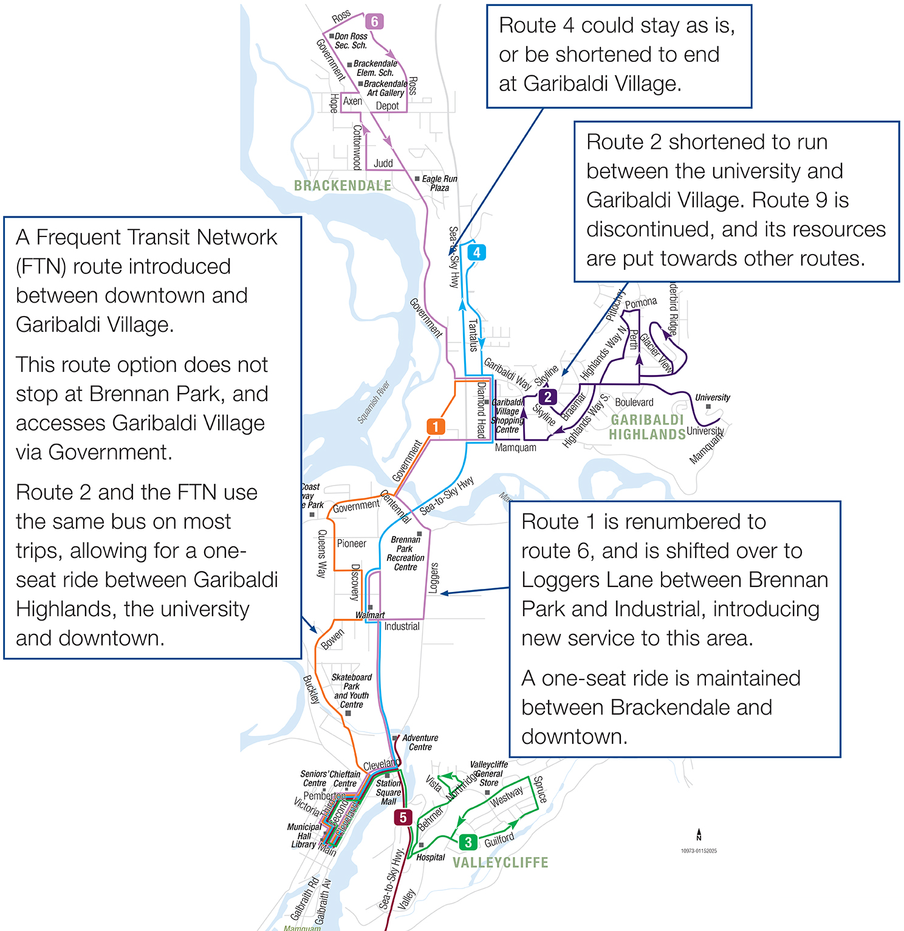

Option 3:

### FTN via Garibaldi Village & Brennan Park

* **FTN replaces part of Route 1** and runs the route of **Downtown – Garibaldi Village – Brennan Park – Capilano University**.

**Route 1 is split as follows:**

* **FTN (new Route 1):** Downtown → Garibaldi Village → Brennan Park → Capilano University.
* **New Route 6 (Brackendale – Downtown):** Maintains service to Brackendale, continuing to Downtown via Loggers Lane and the highway during peak periods.
* Route 2 Highlands is shortened to serve **Garibaldi Highlands → Garibaldi Village**.
* Route 4 Garibaldi could remain as is or terminate at Garibaldi Village.

#### Likely Benefits:

* Brennan Park would be served by the FTN, providing frequent service to the recreation center.
* **Extending the FTN to the university would increase service**
* Longer-term possibility: Extending Route 3 (Valleycliffe) to the Adventure Centre would allow transfers to Route 6 for access to Brennan Park.

#### Drawbacks:

* Extending the FTN to Brennan Park and the university increases travel time and could slow service improvements due to higher costs.
* Route 9 would be discontinued, with its resources redistributed to other routes.

### 